**WHW 3-1**

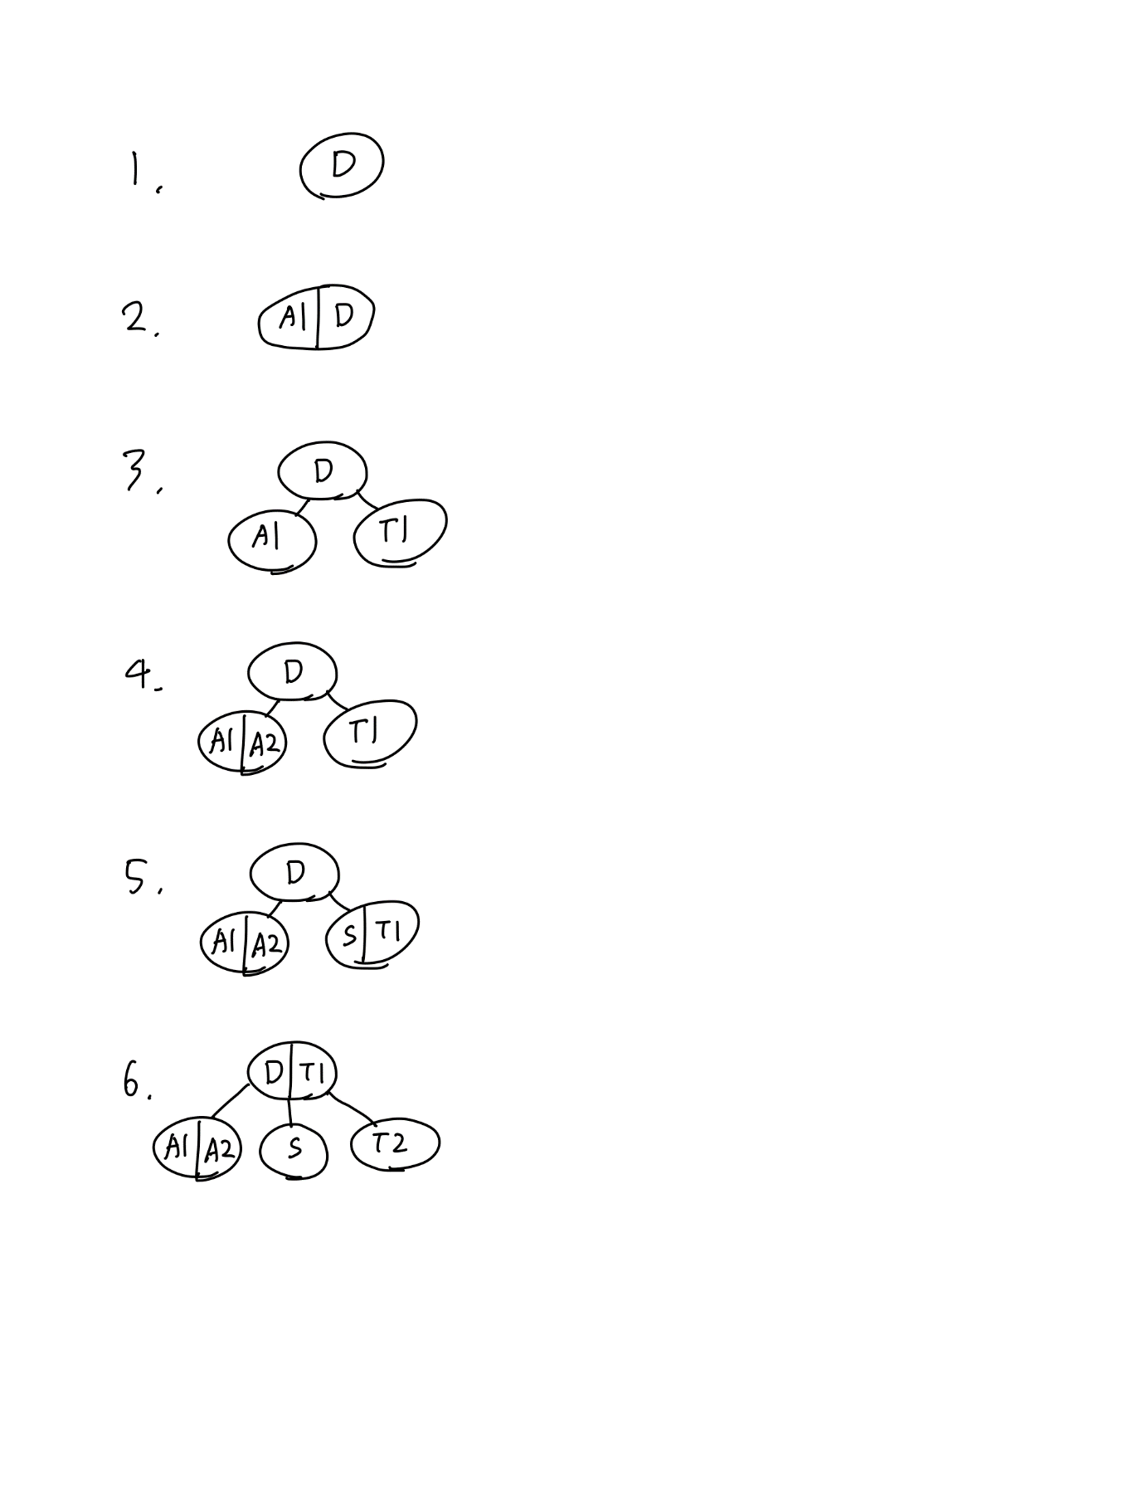

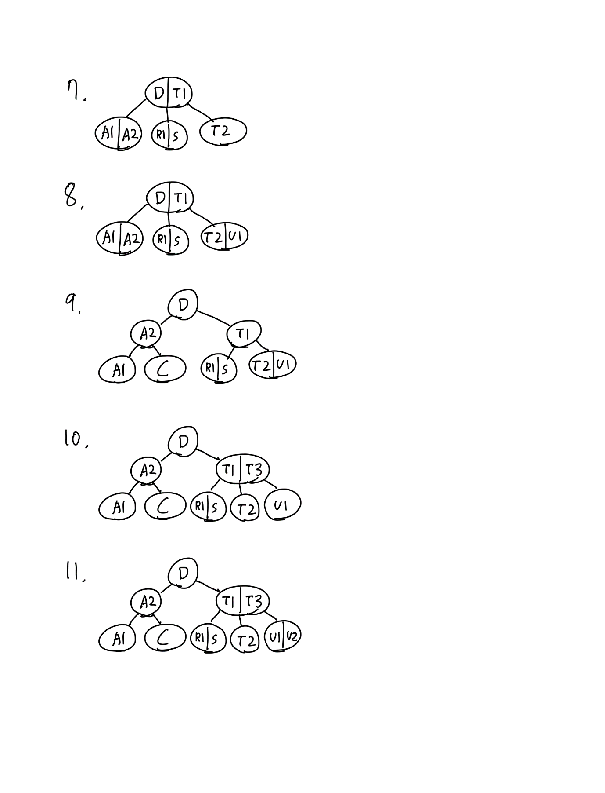

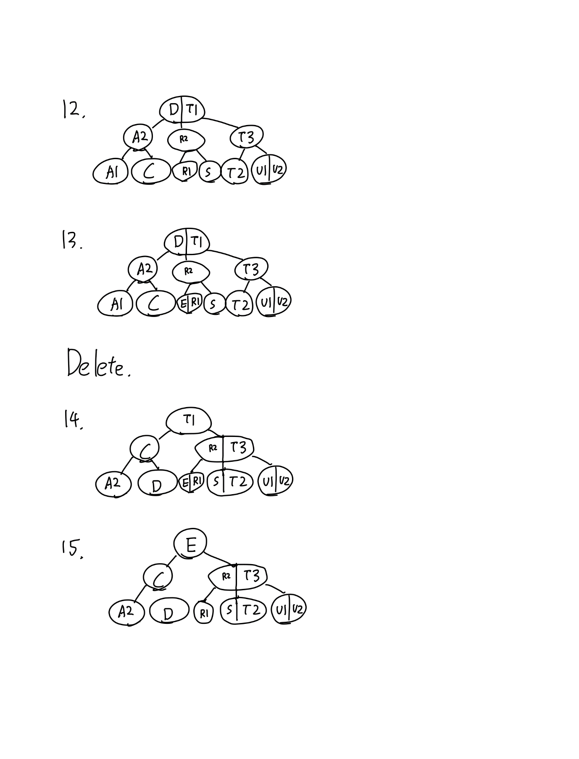

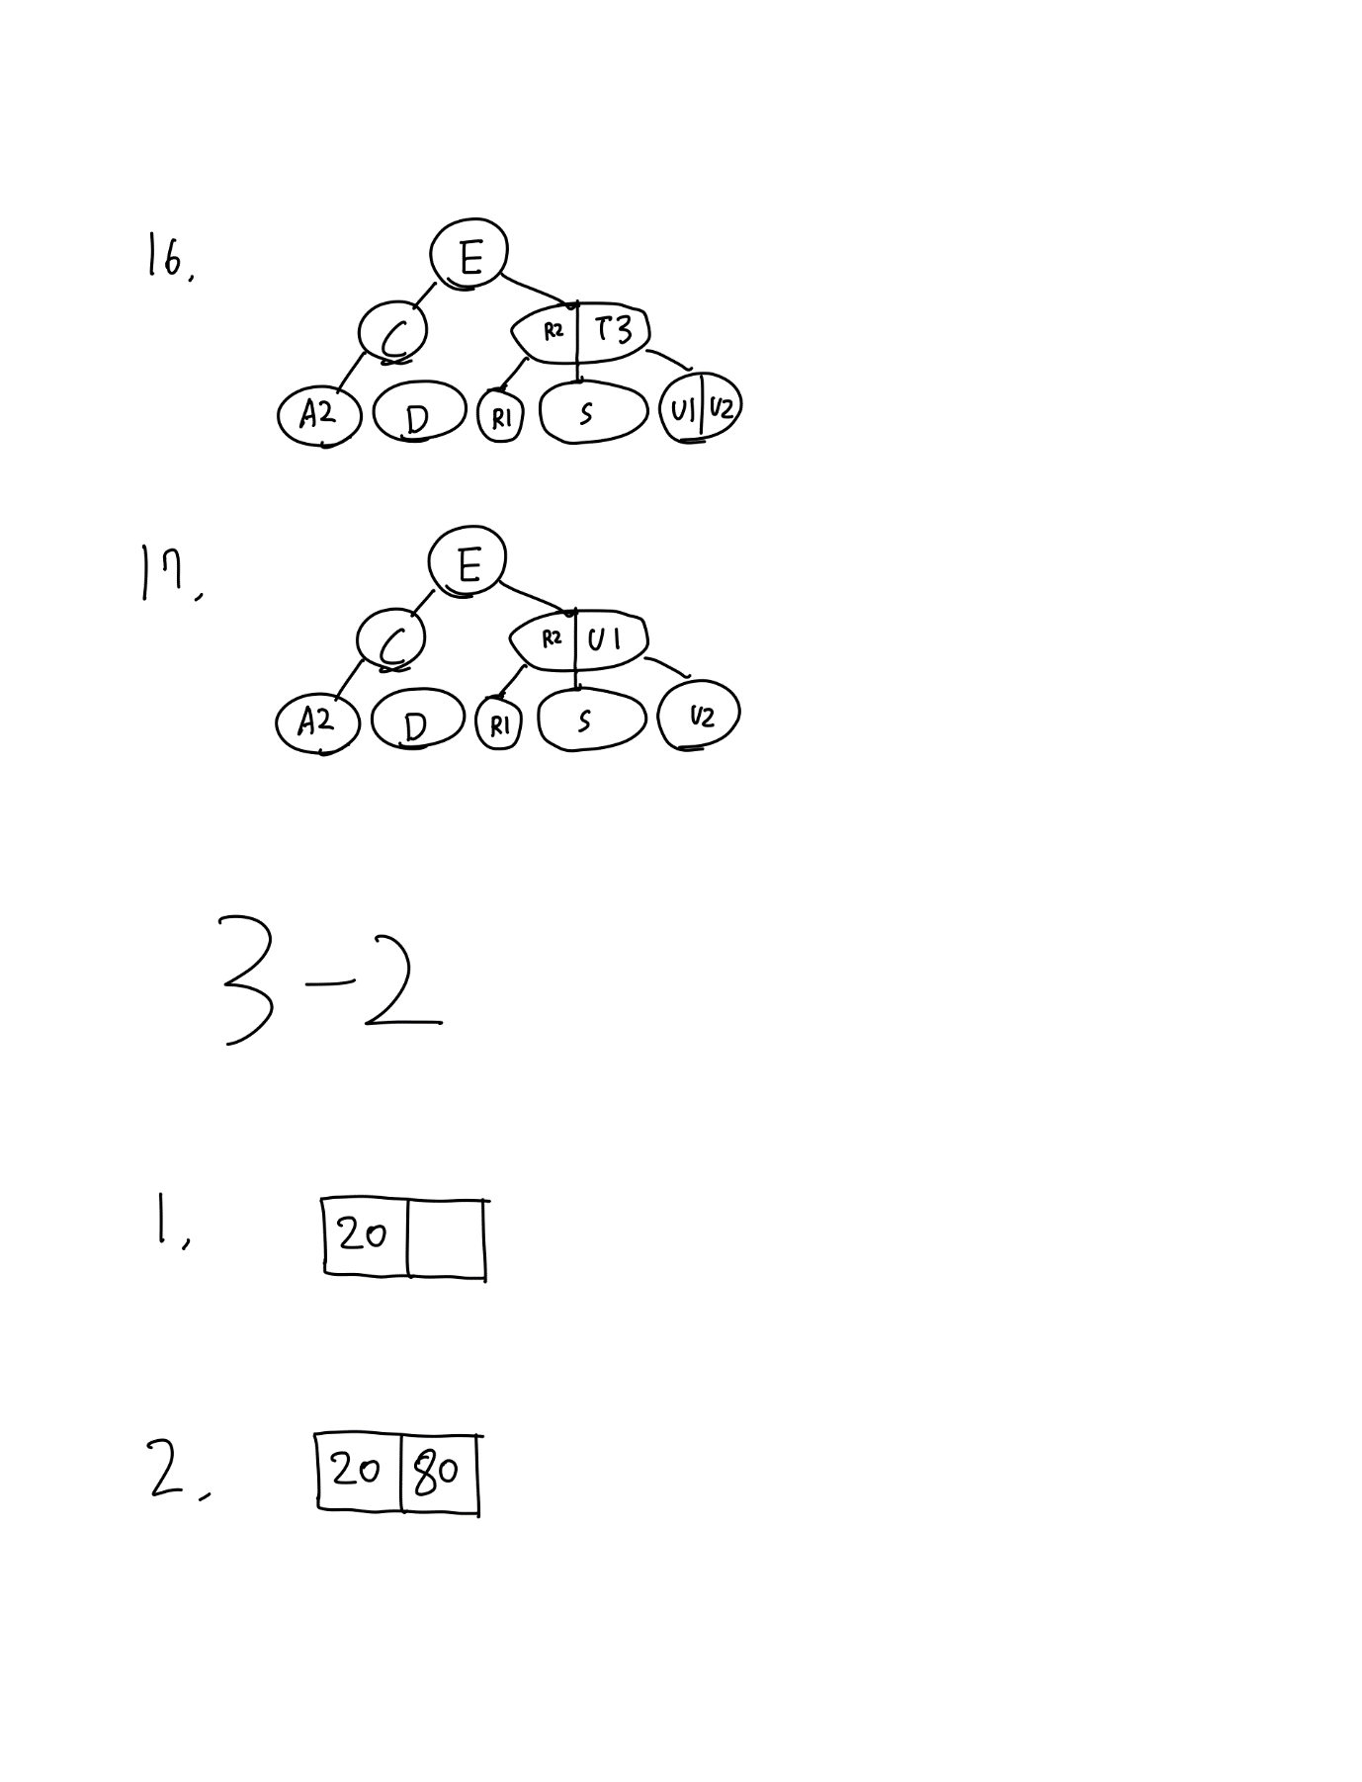

**WHW 3-2**

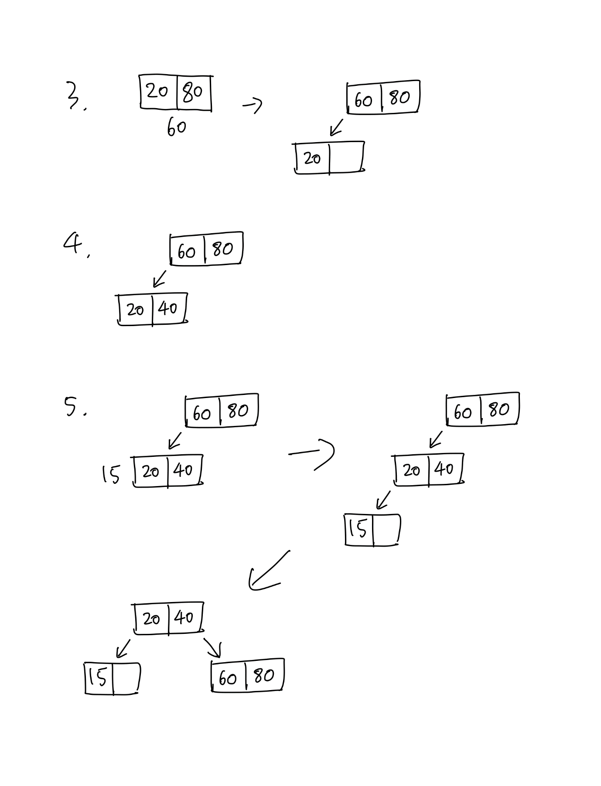

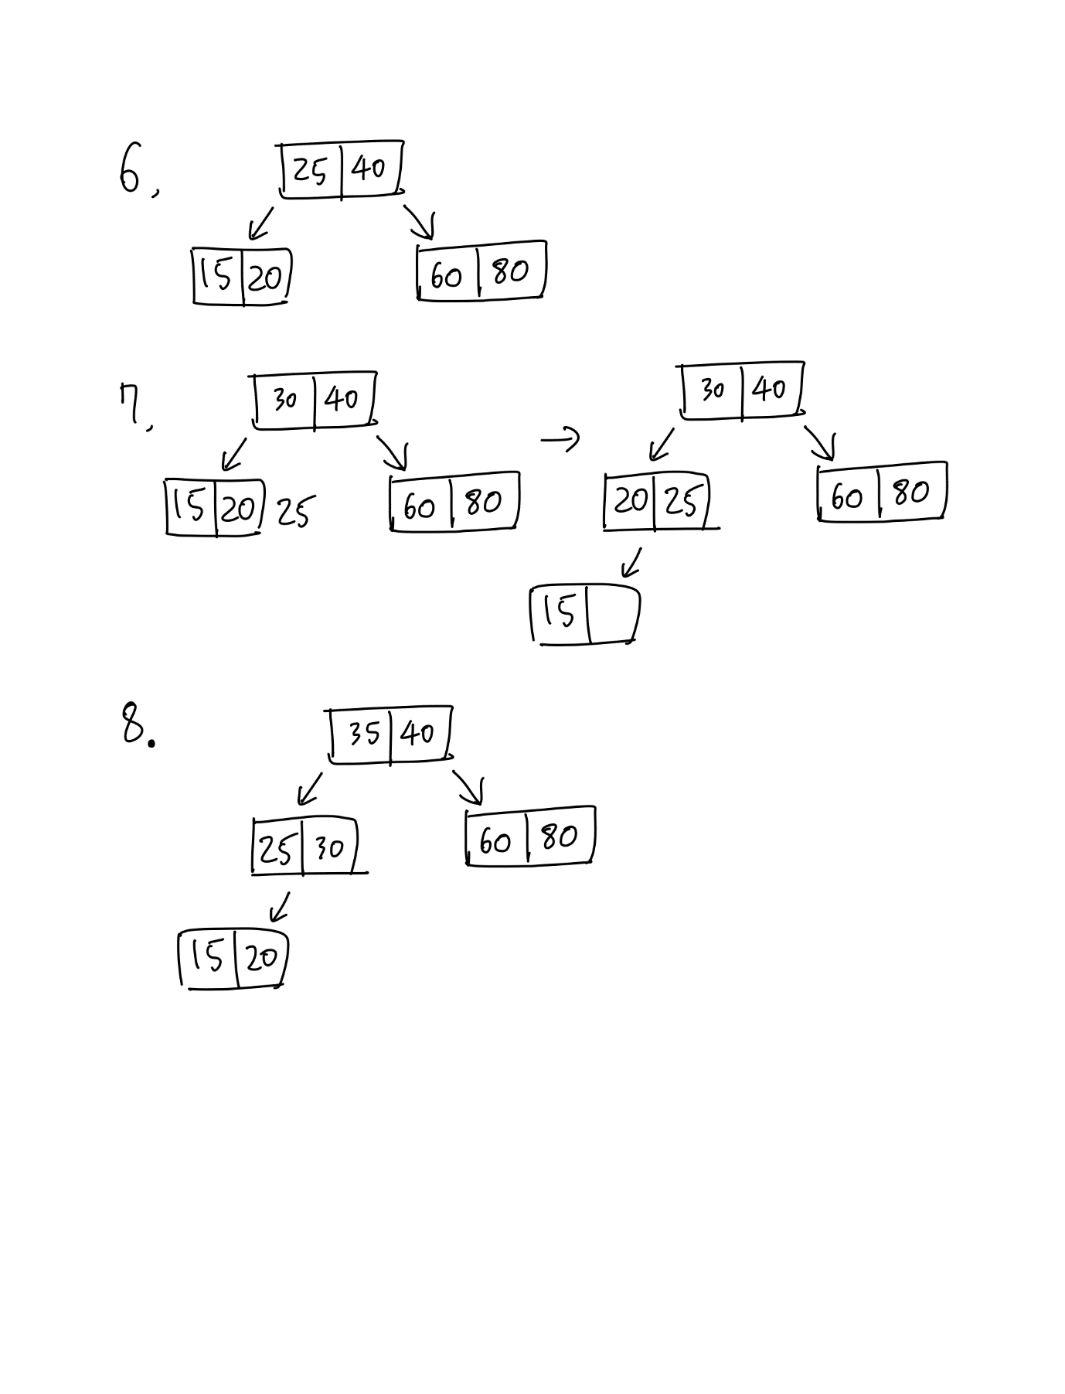

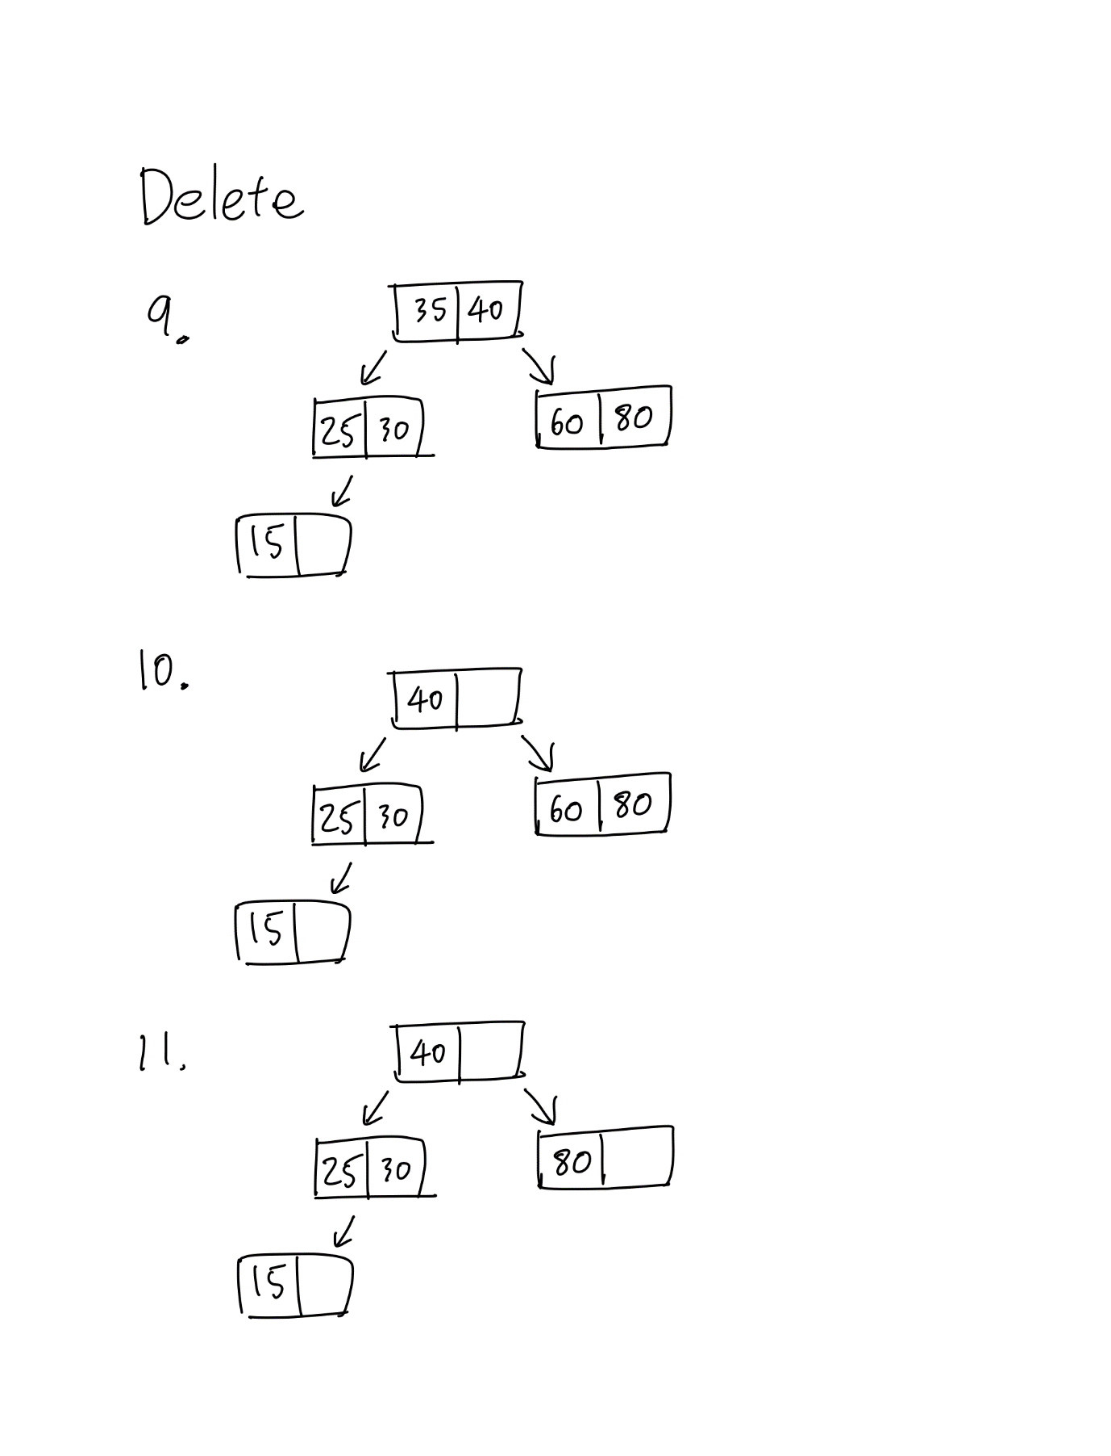

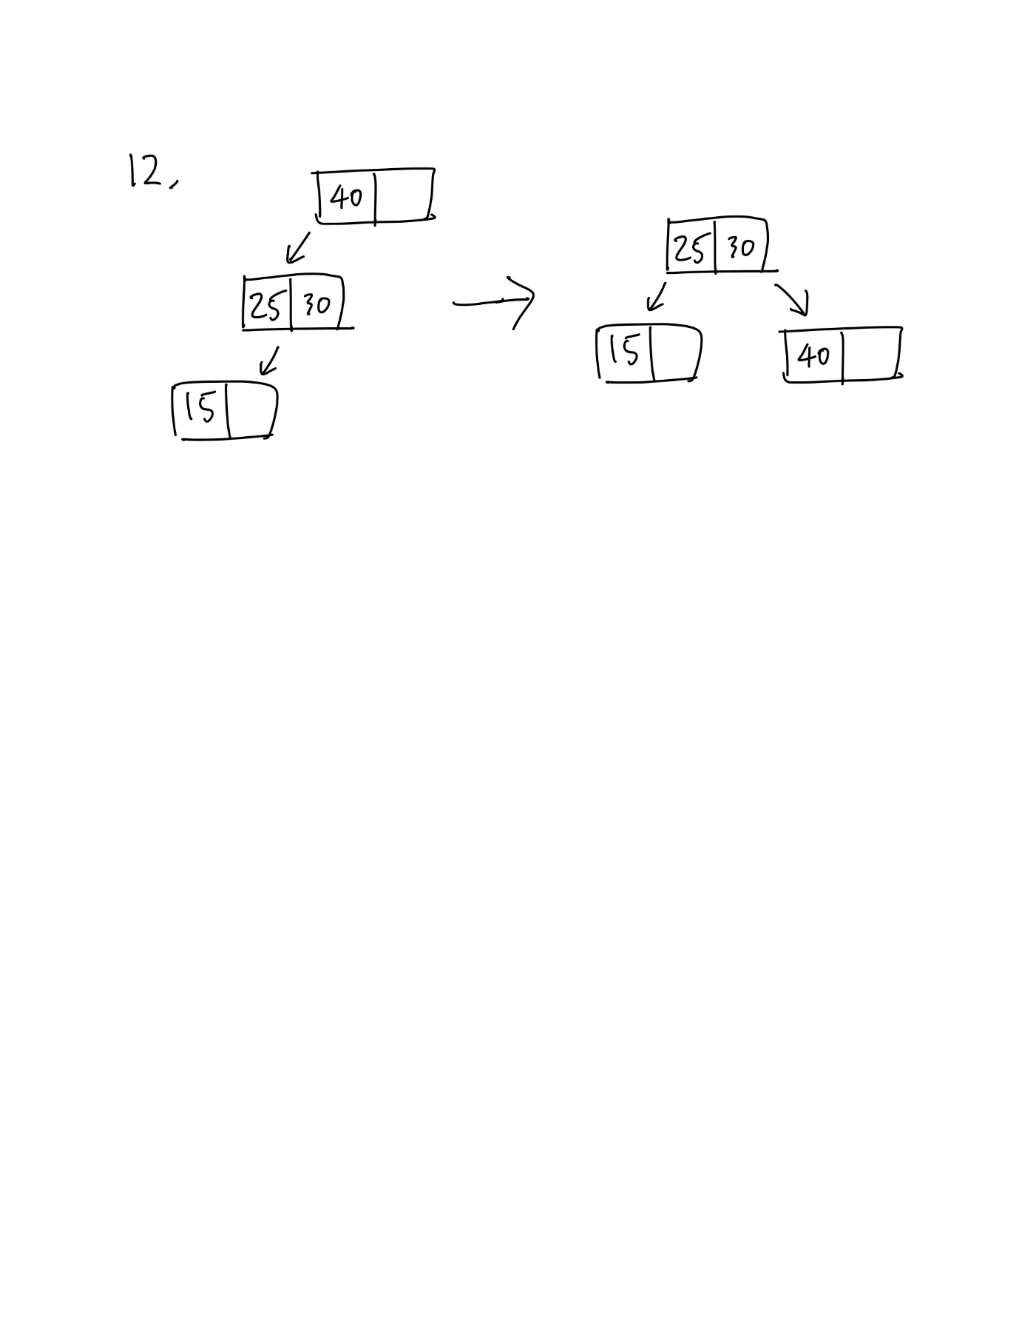

**WHW 3-3**

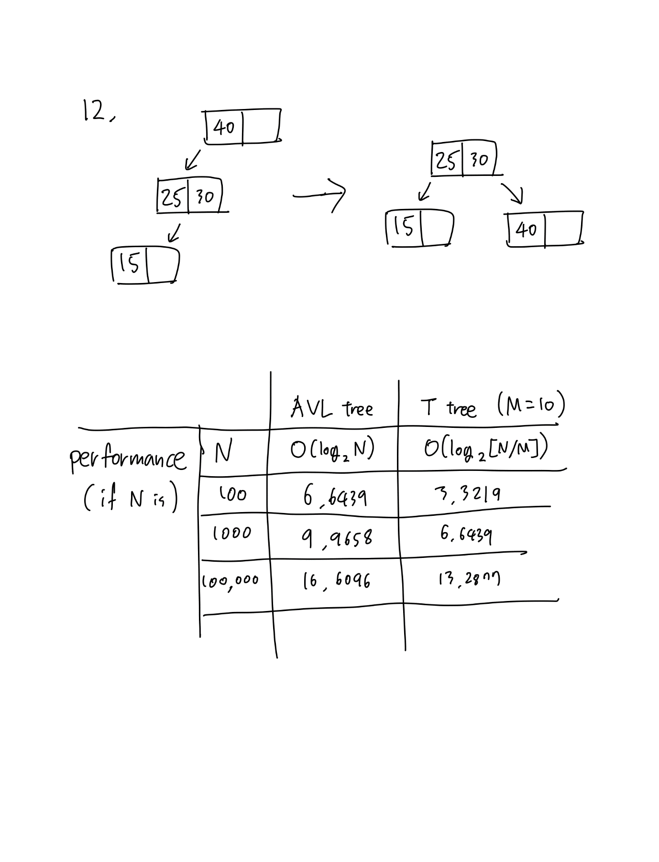

In performance about time complexity, T-tree is better than AVL tree. Because Height of T-tree is shorter than AVL tree. But in Memory requirements, AVL tree is better. For AVL tree, A node with one data is allocated when it is needed. But For T-tree, A node has an array and empty space should maintain as well even though it is not needed. So It can be waste of memory. And when Inserting and deleting in T-tree, process of splitting and merging may be complicated.